Histogram of outcome variable, change in average monthly number of cases per 100 students (Spring – Fall), n= 336

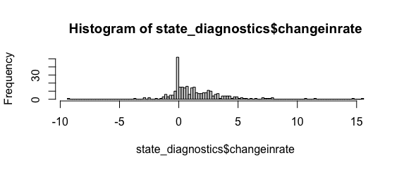

QQPlot of least squares residuals following estimation of multilevel model (this is with the outliers removed). The model appears to have issue with the larger values. 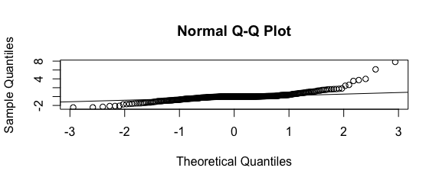

Plot of resids v outcome variable

